**Validation Check for HTML file**

**Board.html**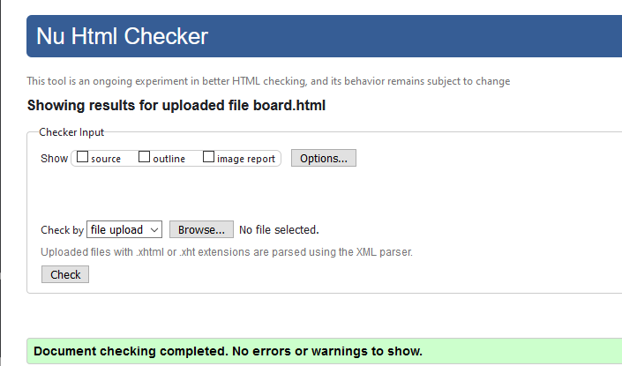

**Validation Check for CSS File**